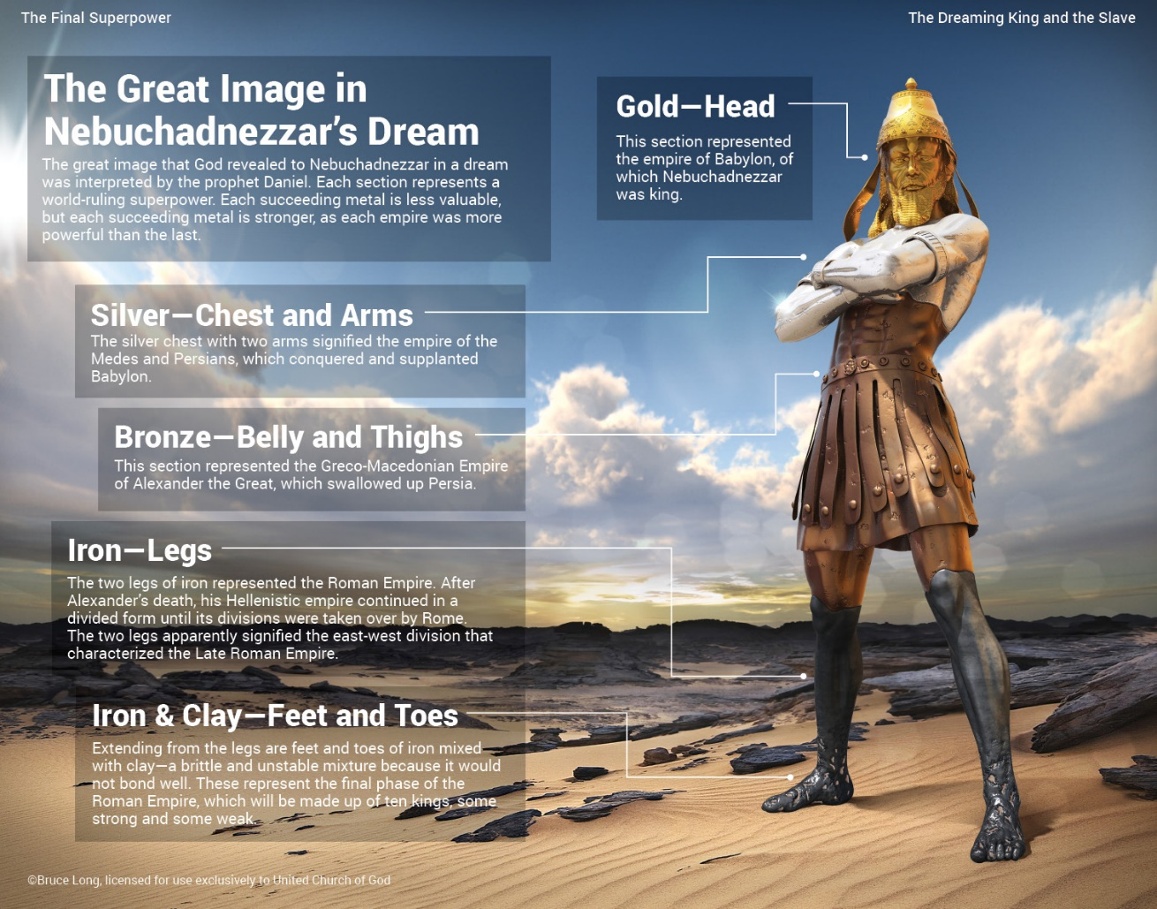
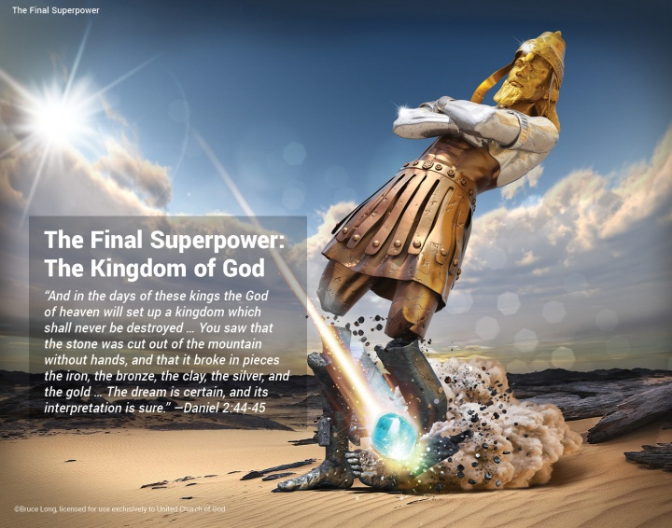

Great Image Artwork: The Final Superpower: A Bible study aid presented by BeyondToday.tv (2014)
Chart of Gentile Kingdoms: Stump, K.W., (1988) The Middle East in Prophecy: Focus of End-Time Events
