Weekly hour long radio program, WKDW-FM 97.5, Sundays 10-11 AM, Northport, FL. Weekly Bible Study, 7:30 PM via Zoom , Current series, History of Church of God Weekly cybercast from Vero Beach, 2: 00 PM, Saturdays

Pastor’s Letter November 27, 2020
To the Non-Repentant
Numbers 32:23 BEWARE lest
YOUR SINS SHALL FIND YOU OUT
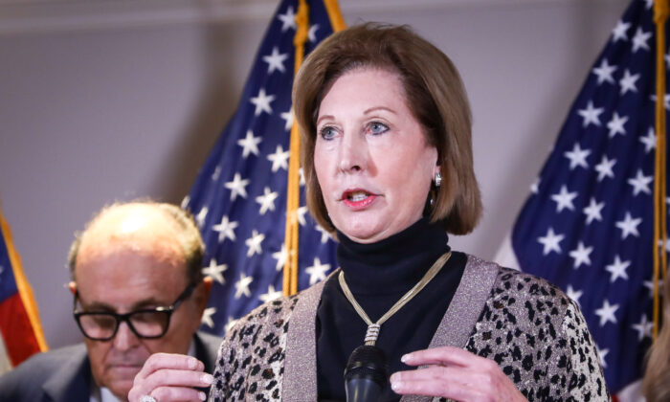

Courtesy of Epoch Times
IF There Is Injustice, Will There Be Justice?
Scandals in this nation are nothing new in America… Watergate, Contra-gate, Travelgate, Iran-gate, Bengazi, Operation Fast & Furious, Operation Abscam, controversy over Joe and Hunter Biden, alleged Voter Fraud, Fake FISA reports, Impeachments, Internal spying, Political intrigue in high places ..and on it goes. This is even true of our ancestors in ancient Israel. There were famous government takeover attempts such as with David’s sons who aspired to illegally replace their father as king of Israel.
First there was Absalom who was very charismatic and devious as he ingratiated himself to the people. It is interesting to note that while an increasing number of Americans claim that certain people stole the 2020 election, people in ancient Israel claimed that Absalom stole the hearts of the people (II Samuel 15:6). Absalom’s associates did nothing to dissuade the people from supporting Absalom.
Then there was Adonijah that thought he could succeed where Absalom failed. Adonijah lined up several influential priests to support him. He also did something that Absalom failed to do…get the support of the military under General Joab. That would be the equivalent of today picking up the support of the Pentagon ‘s Joint Chief of Staff over the military. Adonijah was very clever and calculating. When he illegally announced that he would be the next king instead of Solomon (I Kings 1:5) he induced many Israelites to cheer his sudden coronation.
In both cases, traitors to the throne of David eventually revealed their true colors. A timely scripture in this regard is I Timothy 5:24-25:
“Remember the sins of some people are obvious, leading them to certain judgment. But there are others whose sins will not be revealed until later. In the same way, the good deeds of some people are obvious. And the good deeds done in secret will someday come to light”. (NLT)

The Greatest Scandal of All .. if true
It was announced days after the recent US election that former Vice-President Joe Biden was and is the President Elect. However, increasing information is coming out to suggest that there was massive voter fraud that involved many people in multiple swing states and perhaps other states as well. If proven to be true, such development would be unprecedented as well as breath-taking. No other scandal in US history would come close. The alleged voting of “dead” people in Mayor Daley’s Chicago swung a razor close election to John Kennedy over Richard Nixon in 1960 but the alleged voting scandal of 2020 dwarfs the election of 1960 into microscopic insignificance. Some are even contending that 2020 votes came from outside the US and voting machines were deliberately programmed to alter vote counts. There are grave implications for the nation if such activity is true.

Many people seek to know what Donald Trump’s legal team is strategizing. Others want to know what the Democrats are thinking. However, we must listen for what God thinks. People forget God. They do not realize that He has His own timetable and agenda. They forget that God will respond to all of this controversy in a place and time of His choosing.
God may allow Mr. Biden to move into the White House…or move in and then move out of it, depending on circumstances. God may allow President Trump to remain in office. In Daniel 4:16-17 the Bible states that people are allowed to place themselves in high office if God allows it.
God generally permits mankind to make all of his own choices in life but God also has a responsibility to factor in and respond to the behavior of this nation.
Unfortunately people are deceived into thinking that it is possible to grab authority and power without ultimately answering to God for doing so. Usurping authority is a sin and God will make sure that their sins will ultimately find them out ..unless these same people seriously repent. There is a long list of people who discounted the existence of Numbers 32:23 such as Aachan, Korah, Simon Magus, the Pharisees, Demas, Haman, Daniel’s enemies and Joseph’s brothers. At this point, it seems that illegal forces behind the voter fraud are starting to emerge and will continue to do so in the near future – if God continues to allow it to be so.
Those who are repentant or have nothing to hide need not worry about Numbers 32:23. Here are two recent headlines that indicate that the tide may be turning on the political scene.
PETR SVAB “Thousands of People Registered and voted in Georgia using addresses ofpostal facilities or businesses but making it look like they were residential addresses Nov 24

Crossroads: Video: Matt Mraynard: Evidence of Voter Fraud Enough to Flip States

With so much at stake, we may see hostility and localized war brewing in the future; which further reminds us that this is not God’s world (John 18:36)
…Thy Kingdom Come !!!

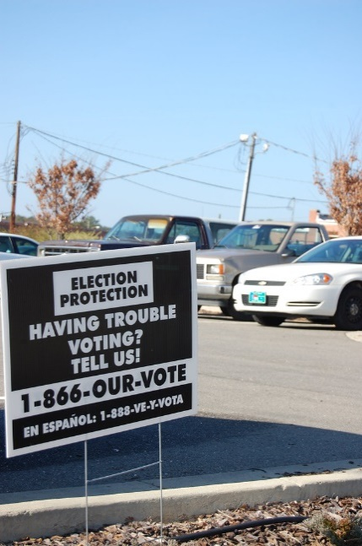
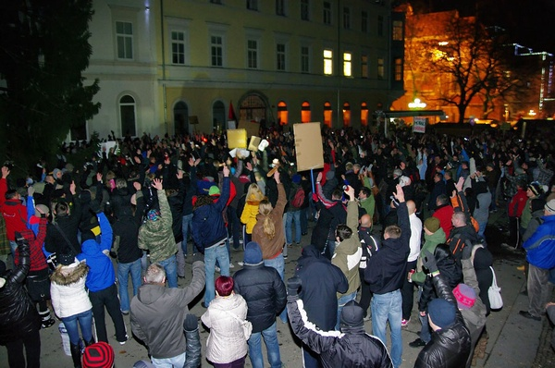

"Voter Intimidation?" by Donald Lee Pardue is licensed under CC BY 2.0 "Unanimous vote for impeachment" by Jumpin'Jack is licensed under CC BY-SA 2.0

Last week I wrote of a baptized inmate who went through a gut wrenching trial to see if he could gain parole. The judge ruled this past Monday that he would be returned to prison to continue his life sentence. Please remember him and the others that he harmed since this was a very difficult and emotional experience for all concerned.
The reason why I wrote about this is to ask for prayers for him and also to show how complicated and painful life gets when human beings break God’s laws. Under God’s supervision and awareness, no one gets away with anything. We should be thankful to be under God’s authority for many reasons.

This week Lonnie Mooneyham will speak in Ft. Myers, Stan Braumuller and guest Ron Wroblowski will speak in Ocala, and I will speak in Vero Beach.
Best wishes for a blessed Sabbath. bv

