Weekly Radio Program, 10-11 AM, WKDW-FM, Northport, FL Weekly Bible Study – currently on History of the Church of God Weekly webcast from Vero Beach, 2 PM.

Pastor Letter December 4, 2020

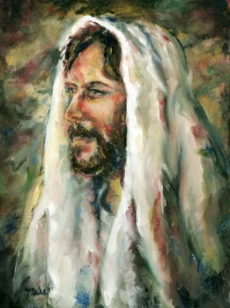

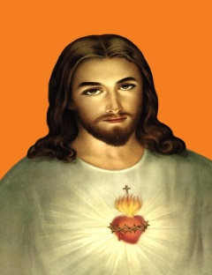
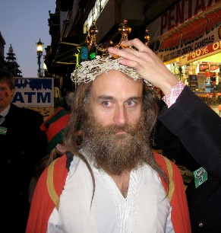

Accept No Decoys
Will the Real Jesus Christ
Please Stand Up

Don’t These Imposters Ever Smile?
Some of them look downright dangerous—and several look as if they have never done a lick of work in their lives. No, I didn’t get these mug shots off past bulletin boards in post offices but I feel sorry for anyone who trusts in the empty worship of such a non-masculine, weak and seemingly powerless person.
As we know, spiritually and physically speaking, Christ was not a weakling. If He were, God the Father could never have imagined utilizing Him to represent the coming Kingdom of God nor could the Father imagine choosing Him to die for the sins of humanity. Instead, the One who became Christ would be known for His quiet strength and unwavering confidence in His Father. Biblically he would be quick witted. Occasionally He would find it necessary to verbally scathe his obstinate critics with quotes out of the Bible. He would be a physical specimen of muscle from his days as a master carpenter. Otherwise He could have never endured so much on the cross nor been able to haul through Jerusalem the stake that he eventually would be nailed to.*
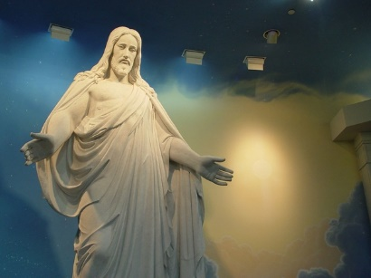
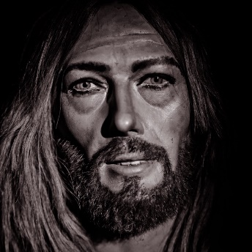
It should also be noted that Christ would have dressed in the conventional styles of the times. He would have been hard to pick out in a crowd with his short hair because men in that day in that part of the world all had short hair. He therefore blended into the crowds with His appearance and successfully eluded his enemies (Luke 4:29-30) (John 8:59)
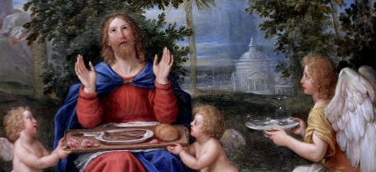

Approximately a century ago author Bruce Barton wrote about Christ and entitled it The Man Nobody Knows . That was an appropriate title because people really do not know who Christ is. Many think he was a long-haired hippie type that subsisted out in the woods and died of a broken heart. Growing up I assumed He existed but I wondered why Christ appeared to be so powerless to do anything (at least that was my perception).
Contrary to Public Opinion,
- Christ did not come to do away with God’s law
- He did not come back to win a popularity contest with society
- He did not come to bring peace. He said, “Think not that I come to send peace on this earth but a sword
- He did not return to establish His future Kingdom ..yet. Society expected Christ at His first coming to return as the Lion and He came instead as the Lamb; soon He will return to this earth as a Lion and society will expect Him to return as the Lamb
- Christ was not born on or near December 25 but in the Fall
- He did not die of a broken heart

When Christ does return to the earth, His real appearance will be so different than how others have falsely portrayed Him. His eyes will be like flaming fire and His clothing will be brilliant white. He will have a bionic powerful body that is so bright that no one human being could look on Him and live. The book of Revelation says He has the voice of many waters which suggests that He can bellow out a deafening roar that could blow out peoples’ eardrums. That alone is a good reason why no man has seen Him or heard His voice. (John 1:18, 5:37).

But since we know these things -why discuss them here?
– Because we may undervalue these blessings in our lives !

Because we can’t afford to recreate God in our image. We cannot relegate Christ to human status else we not recognize His true and complete abilities.
More than just a friend, Jesus Christ is our Lord and High Priest. He intercedes for us (Hebrews 4:14-16) and is in a position to forgive us of our sins. He is the hero of our lives which is epitomized in John 3:16. He can be so much help to us in the challenging future that is in front of us.
- He is our healer and by His stripes we can be healed
- He is the author and finisher of our salvation.
- He is the revealer of God the Father
- He is the ultimate revealer of Bible Prophecy

No picture or description of Jesus Christ can do Him the justice that He truly deserves.
The real Christ has stood up!
__________
* Matthew 27:31-32, Mark 15:20-21, and Luke 23:26 all reference Simon of Cyrene being made to help bear the cross. John 19:17 says “He went out bearing His own cross.” Considering all that He had been through previously, He had undoubtedly become too exhausted to carry it any more on His own and it was at that point that the soldiers pressed Simon of Cyrene into service.
Depending on how Luke 23:26 is to be interpreted, “made him carry it behind Jesus” could mean either that they both carried the cross (one in the front, one in the back) or that Christ carried it as long as He could and then received help to carry it the rest of the way.
SERVICES THIS WEEK

FT MYERS
Jeff Lockhart will speak in Ft. Myers. He also has helped with the Vero Beach webcast, for which we are grateful. We anticipate one or two visitors tomorrow.

OCALA Cort Greenfield and I will speak. A recent visitor to the congregation called me to thank the brethren for being so hospitable and friendly.
The Greenfields have been sharing their extensive gardening experience at their home in the Ocala National Forest and teaching how to successfully store and can their grown produce. We are very appreciative.
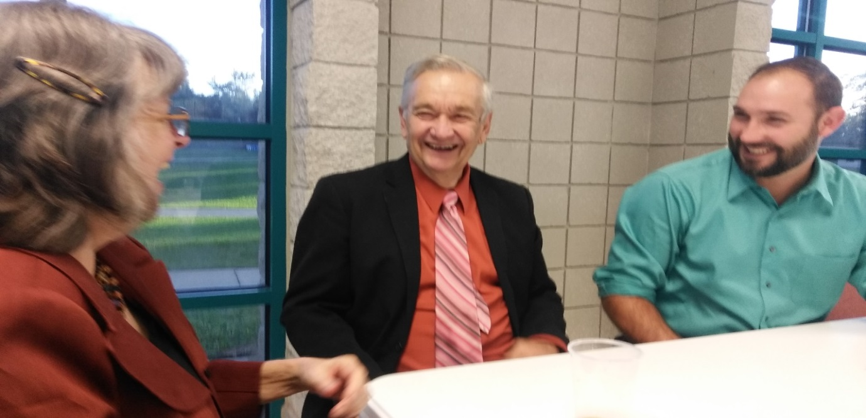

TALLAHASSEE
Tallahassee will not meet this coming Sabbath, but next Sabbath at the Marriott Hotel at 1972 Raymond Diehl Rd. at 2:30 PM. Ron Wroblosky and I will conduct church services. We will have a potluck meal that Sabbath.
This Sabbath, many of the brethren are attending a weekend campout with services in Jacksonville. For further details, you can call Mike McCarty at 850-491-1701.

VERO BEACH
With many thanks extended to Dave and Dianne Waggoner, we have a very strong webcast now. It has been a challenge for us to reach this point. We will likely tweak our effort but the major work for the webcast is now complete.
Last Saturday evening, many brethren stayed until 9 PM playing an absorbing Bible game that engendered various smiles and occasional laughter. It is good for brethren to take advantage of the opportunity to meld together as family.
This Sabbath, Bob Orosz will speak and be webcasted.

"Jesus Christ (Sacred Heart Image)" by Saints and Blesseds is marked with CC PDM 1.0 "IMG_4709A Francesco Albani 1578 1660 Bologne et Rome Jésus Christ servi par les anges. Jesus Christ served by the angels. Grenoble. Musée des Beaux Arts." by jean louis mazieres is licensed under CC BY-NC-SA 2.0 "Jesus Christ - Christus Statue" by midiman is licensed under CC BY 2.0 "Jesus Christ" by p-duke is licensed under CC BY-NC 2.0 "Post Rapture Jesus Christ" by Thomas Hawk is licensed under CC BY-NC 2.0 "Jesus Christ Accepts Crown of Protection" by Sir EDW is licensed under CC BY-NC-ND 2.0

