Bible Studies, Wednesday evenings, 7: 30 PM, this Wed.,History of God’s church, from 1940 – 1980 Radio Broadcast, Sundays 10-11 AM, WKDW-FM 97.5 Cybercast Saturdays from Vero Beach, FL., 2 PM

Pastor’s Letter, February 5, 2021

How Big Is God’s Church ?

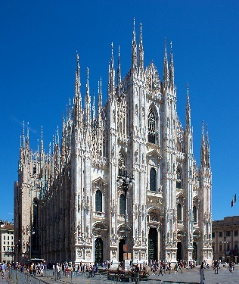
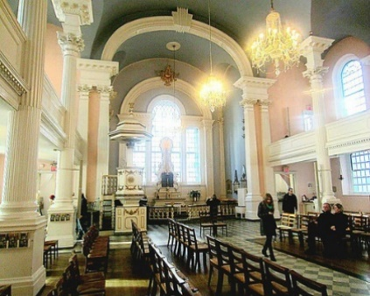
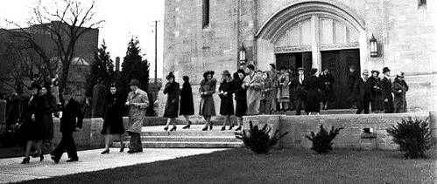

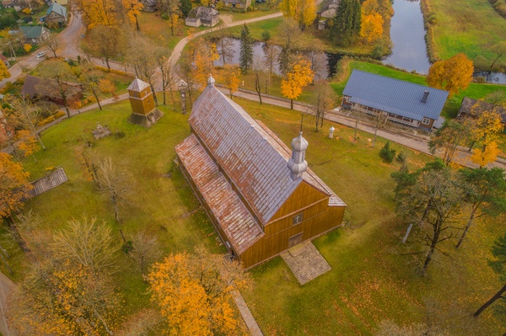
Milan St. Paul Cathedral – New York City Cathedral Interior

Rural RCC Big Enough ! in Europe

But it’s so small !! Yes, by comparison to other religions, God’s church is so small… But with some congregations in single digit numbers and perhaps a mere 100-200 brethren in the largest US cities, what makes God’s church “Big Enough” ?
What potentially makes God’s church “big enough” is God’s presence in it. With God, all things are possible” (Lu 1: 37, Mt 19: 26). With God, all decisions can be inspired. With God, all sermons and Bible Studies can be inspired. With God, we can advance forward and never be alone (He 13: 5). As long as we draw close to God, He will draw close to us . (James 4: 6-8) That is why we can approach the fulfillment of God’s assigned work for us to do because He promises to play a major role in helping us.
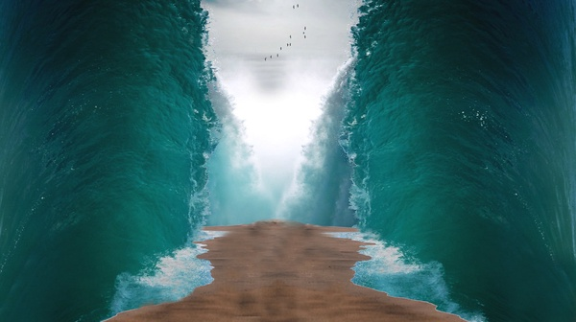

The Great Escape !

“Big Enough” to provide way of escape through the Red Sea

He never intended for us to do His assigned work on our own although at times it might seem as though He has. Zechariah 4:10 reminds us not to despise the day of small things (including small congregations). God told us through the pages of the Bible that His church would be a “little flock” and that it would never be a giant human ecclesiastical movement. Unfortunately for the masses who remain deceived as to where God is working, many people incorrectly expect God to dominate the worship of the largest church denominations in the world. Surely at this late date we should know that a high number of members or a very large building to meet in does not guarantee God’s endorsement. True success in living God’s will for us comes from being obedient to God.
Of course God has a strong opinion of what is necessary to finish the great commission that He has given to His church (Matthew 28: 18-20). God helped Joshua and his army defeat the Philistines and in Joshua 10 the Bible explains that more people died from God’s activity than from Joshua’s army. In Judges 7, God whittled down the fighting force of Israel by 90% and then did so again. God has never been concerned with “the numbers” as He has been with the character and the spiritual vision of His people.
God utilized just 8 people to preserve the human race when He allowed a total flood to envelope the earth. God inspired the Apostle Paul and a few assistants to preach the gospel to Macedonia against all odds. It was here that the general public claimed that these men “turned the world upside down”. Such impact!
Could all of that really happen on mere human effort alone?....or is there a God in heaven which can orchestrate the outcome of human events as is necessary. But too often we give excessive credit to God’s human servants and ironically do not give enough credit to God Himself. Christians have a significant part to play in the fulfillment of God’s work but they can never be infallible or a replacement for what God needs to do.

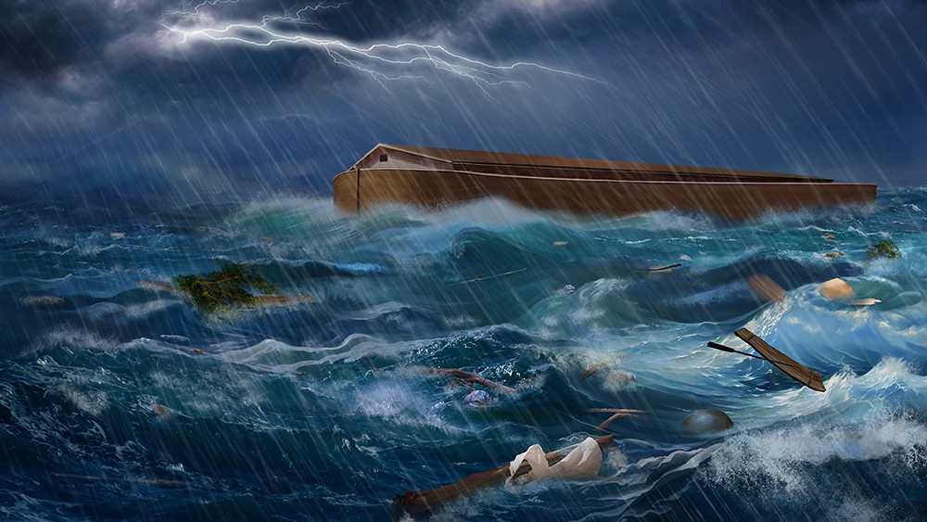

As we move into the future we will rely on God more and more to make up for we are unable to do on our own. For so many reasons this should hardly surprise us. The underlying question is: Are we up to the challenge that God sets before us to collectively fulfill God’s work assignments for us? The choice remains ours to make but as we should know by now, we have less and less time to act.
This coming Sabbath:
OCALA We will meet at the Marion Oaks Community Center where visiting elder John White will give the sermon. .Services begin at 1: 30.

FT. MYERS Bob Orosz will give the sermon in Ft. Myers with church services beginning at 1: 30

TALLAHASSEE And I will speak this Sabbath in Tallahassee at 1: 30 at the Marriott Hotel (1972 Raymond Diehl Rd. near I-10)

Let us internalize evermore what God promises us: We are not alone and God will insure our success if we access His aid and assistance.

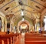
"File:Milan Cathedral from Piazza del Duomo.jpg" by Jiuguang Wang is licensed under CC BY-SA 3.0 https://search.creativecommons.org/photos/e49b0be8-a13f-4f6a-a824-f0b1d2d67b8c#panel2"Saint Paul's Episcopal Chapel, 209 Broadway, New York City. Standing in the shadow of the World Trade Center, St. Paul's was completed in 1766 and is the oldest surviving church building in New York City." by John Wisniewski is licensed under CC BY-ND 2.0 This image was marked with a CC BY-NC-ND 2.0 license "File:Alsėdžiai Church Building Complex of the Immaculate Conception of the Holy Virgin Mary 130 - A.jpg" by Žemaitijos kelias is licensed under CC BY-SA 4.0 "File:Alsėdžiai Church Building Complex of the Immaculate Conception of the Holy Virgin Mary 130 - A.jpg" by Žemaitijos kelias is licensed under CC BY-SA 4.0 "The Time of Noah | picture of the Church of Almighty God" by jasonchen.gg is licensed under CC BY-NC-ND 2.0 "Parting of the Red Sea" by Iforce is marked with CC0 1.0

