Weekly Bible Study Wednesdays, 7: 30 PM, continuing History of God’s Church, 1970-2000 Weekly broadcast WKDW 97.5 FM, Sundays 10-11 AM Weekly webcast, Saturdays from Vero Beach, 2 PM

Pastor Letter February 12, 2021

..What Does it Take
to Get Peoples’ Attention?

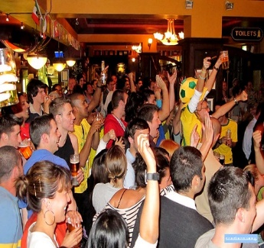
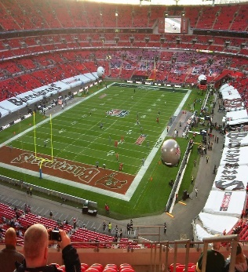
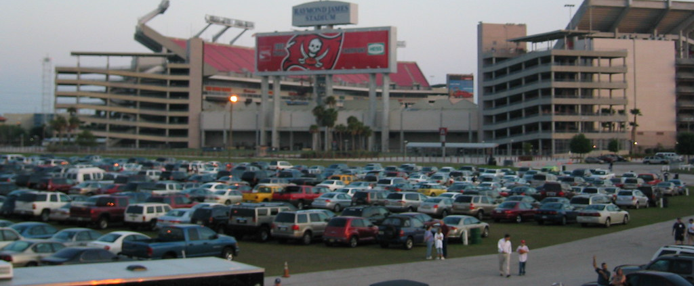

For some, rooting for the NFL champion Tampa Bay Buccaneers is not a matter of life and death – it is more serious than that. So says some of their more diehard fans; but what would it take for people to get as excited about God’s kingdom ?
It would require God to do the unthinkable.. It would require God to take away from people all of their idols. That’s right…take away the Super Bowl, the World Series, the Stanley Cup, #12, #99, #7, AND MORE;..it would require God to take away yachts, certain cars, status, certain homes, prosperity, security, freedom, stock markets, music idols, television and Hollywood. While attention to some of this list may be reasonably ok, inordinate obsession with any of these items can become addictive and self-destructive. Just as Romans 6:16 states, whatever people hold inordinately dear to themselves is what they obey and worship:
“ Don’t you realize that you become the slave of whatever you chose to obey? You can be a slave to sin, which leads to death or you can chose to obey God, which leads to righteous living. (NLT)

I have met people who gambled away all of their savings and then gambled away their home to end up on the street. I met a man one time who became so addictive to video games that he lost his wife over them. I knew another person who lost his home and then had the agonizing experience of informing his innocent wife that suddenly they had no place to live.
We unfortunately live in a world of addictions. Alcohol, drugs, work, pleasure, food, video games, television, tobacco, sports and gambling…they are many and they are everywhere. It is so tragic when people get entangled in these webs of self -strangulation… yes, people can become their own worst enemies.
If we do not destroy or escape from the past idols that have separated us from our God, then God claims that He will get rid of them for us. The difficult reality will be that the longer we persist in worshipping that which should not be worshipped, the more painful it will be for God to dislodge the idolatries from us.

wHY Pick Your Poison when you can join Multiple Millions
who have conquered their addictions ?
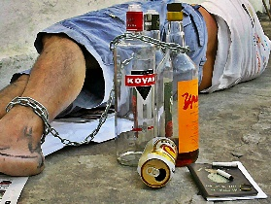
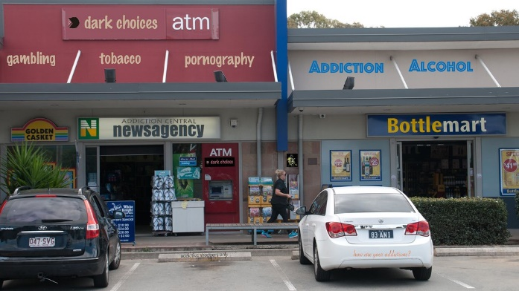
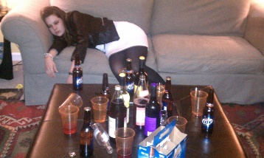

Everyone worships something…a car, a lifestyle, a football team or drugs or ????
But it doesn’t mean that we have to be the next addict nor become obsessed with following unbridled sinners nor harbor any pursuits of other interests ahead of allegiance to God
Time is running out on this increasingly Godless civilization as people show the proclivity to be interested in anything else rather than the true God. It will probably take a major crisis for most of mankind to even consider getting acquainted with Him and His way of life that brings about true happiness.
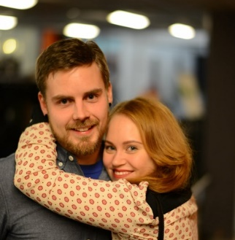
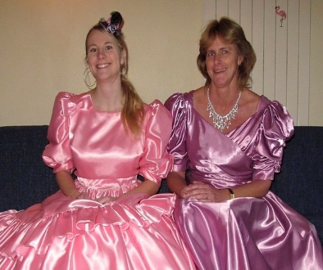
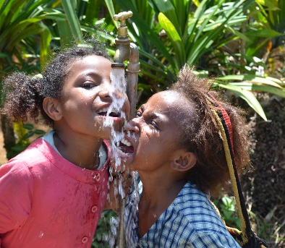

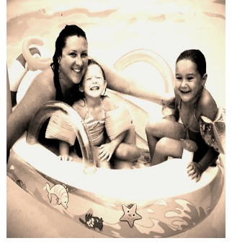
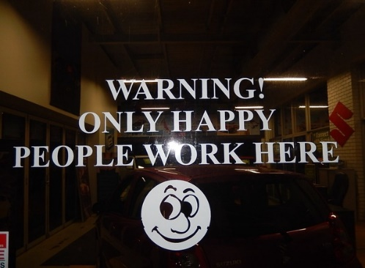

As will always be customary, I urge all of us to read Mr. Kubik’s weekly letter discussing the wider range of church activity both here and abroad. Also it is valuable to read Mark Welch’s observations that are included in Mr. Kubik’s letter.

Local activity
OCALA
Moses Summers will be giving the sermon in Ocala this week. And the following weekend we will have a pot luck meal. It has been nice having elder John White in the area and, just maybe…if we somehow are able to take the wheels off of his car and hide them, we may be able to keep him and Vicki with us for extended time. Services begin at 1: 30.
FORT MYERS
Much thanks goes to Bob Orosz who spoke to the brethren last Sabbath. I will be there this week to keep the ball rolling. At this time of year we become increasingly conscious of the upcoming Holy Days and as we approach them, in our messages we will need to be turning our attention to Christ’s sacrifice
TALLAHASSEE
We spent time last week with various brethren on our travels including one large family who lives far away but has chosen to attend with us as they can. This week Mike McCarty will manage services at our location in Havana. Services will start at 1: 30. Below is a collage of Tallahassee brethren from last month at “the farm,” at Havana, just outside Tallahassee.
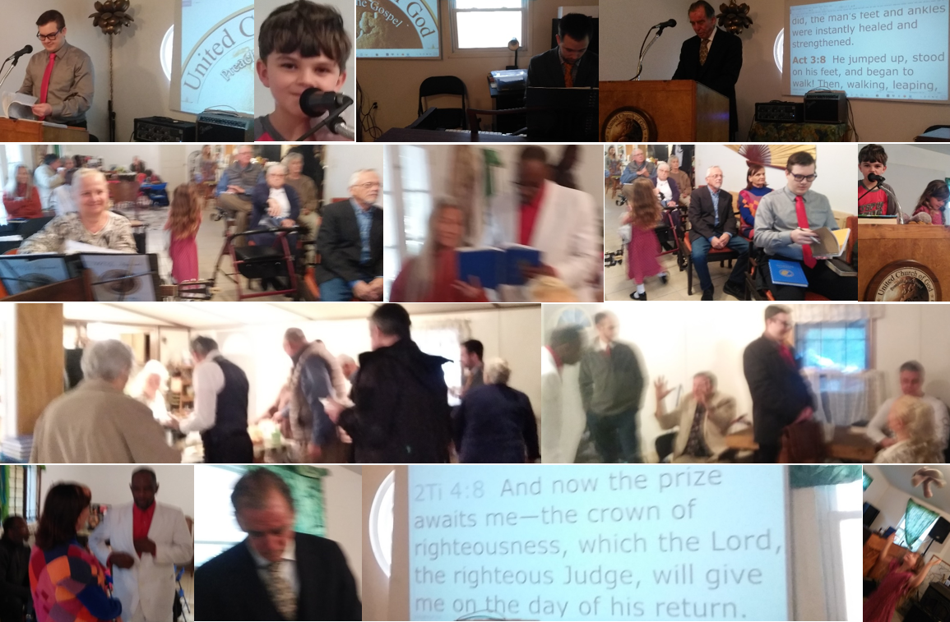

y eGuide Travel is licensed under CC BY 2.0 "alcohol slave" by Imagens Evangélicas is licensed under CC BY 2.0 "Alcohol Poisoning PSA Video Shoot" by stopalcoholdeaths is licensed under CC BY 2.0 "New England Patriots @ Tampa Bay Buccaneers, 25th October 2009" by Noelinho.org is licensed under CC BY-NC-ND 2.0 "Tampa Bay Buccaneers Stadium" by JeffreyPutman is licensed under CC BY-NC-SA 2.0 "Brazil football fans, London" by adrian, acediscovery is licensed under CC BY-NC-ND 2.0 "dark choices" by Leonard J Matthews is licensed under CC BY-ND 2.0 "Shiny happy people" by Paula Satijn is licensed under CC BY-ND 2.0 "Shiny happy people" by Paula Satijn is licensed under CC BY-ND 2.0 "Happy people in the evening" by Henry Söderlund is licensed under CC BY 2.0 "Shiny Happy People Smiling" by Marc Forrest is licensed under CC BY 2.0 "Beware Happy People" by mikecogh is licensed under CC BY-SA 2.0 "Happy People! II" by aha42 | tehaha is licensed under CC BY-NC 2.0

