Weekly Radio broadcast, Sunday mornings, 10-11 AM on WKDW-FM 97.5 FM, Northport, FL Weekly Bible Study, History of the Church of God 1990-2021, 7: 30 PM via Zoom Weekly Sabbath web casts can be found on the Vero Beach, Orlando, Tampa & St. Petersburg websites

Pastor’s Letter, February 20, 2021

Space Aliens -
Cheap Counterfeits
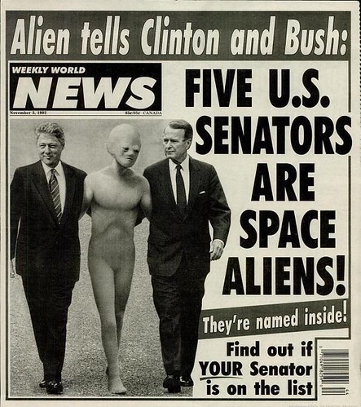
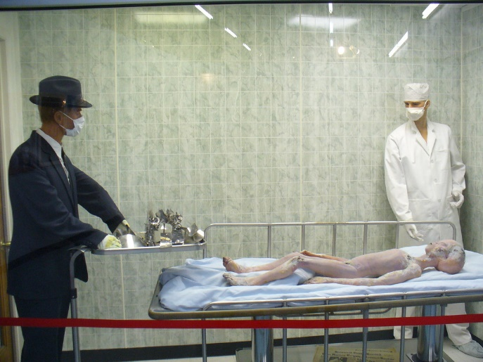

Alien on the Loose Autopsy Performed on Captured Space Alien Aliens in High Places Coming to a town near you? How do we know if this one is really dead? Are some in your family ?

Amazingly, many people are enamored with Space Aliens. Why? Is it that space aliens are a superior race? Do they supposedly dart around the Earth in advanced UFOs to spy out defiant earthlings who may fight them for control of the planet?
Some people fantasize a futuristic society complete with space travel accompanied by new scientific inventions and they hope that aliens will introduce that technology to this world. More than this, other people on earth have hoped that space aliens would save earthlings from themselves. Yet others envision space aliens as coming as invaders to take this earth over…..but.. somehow none of these things have happened.
In the late 60s Frank Edwards wrote and published a book entitled “UFOs – Serious Business” which drew much attention. In his book he claimed that space aliens would make overtures to various world leaders. Obviously other material has been written on the subject of space aliens but so far, no one has been able to convince most people that they even exist.

Oh, Would People ever be Shocked if they only knew…
However, did you know that the Bible does talk about beings from outer space? It is indeed true but God is not talking about anemic looking aliens on flying saucers. Through the pages of the Bible God reveals that there is a force of billions of beings in outer space that assist God in managing the affairs of the universe. We identify them in the Bible as spirit beings or angels.
As an example, God created billions of angels that work with Him. As the book of Psalms and the book of Revelation illustrate, millions of them are musical and play harps, blow wind instruments and sing in perfect harmony. Some move with great power. (Isaiah 6:4) As also described in the book of Revelation, these spirit beings generate a lot of noise when they signal monumental events that subsequently take place. (Revelation 8:6-13 and I Thessalonians 4:16)
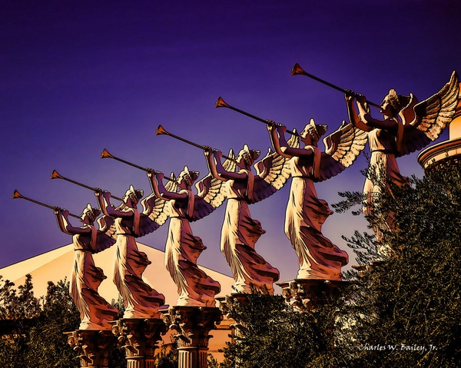
According to Hebrews 1:14, these individuals who dwell at God’s throne or in other assigned locations are servants to humanity…a total contrast from the idea that they are space aliens lurking on earth seeking to take it over or exploit certain earthlings.

Powerful Influence & More Than A Match for Space Aliens
It may be that you have been at times protected by these “aliens” They really are some of our best friends. They vividly grasp God’s plan of salvation and rejoice when God’s people repent (Luke 15:10). On occasion, they intervene to help us (Acts 12:7-10 and II Kings 6:15-17). At times they are messengers (Matthew 1:20 and Daniel 10:9-21) and sometimes they are given responsibilities to administer God’s punishment (Genesis 19:11-13). In every case, angels that obey God always act in the best interests of the Creator and the created. The alleged space aliens displayed at the beginning of this letter are merely cheap imitations of real servants from outer space, including the greatest extraterrestrial being from outer space, Jesus Christ. Let us appreciate the statement included in a recent advertisement, which says: ‘Accept no decoys’.

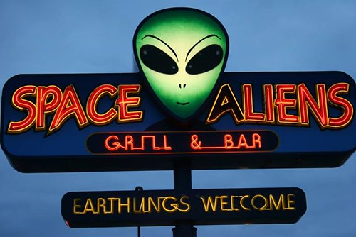

Cheap Counterfeit

Please take the time to read Victor Kubik’s letter to the brethren (sent earlier) that steers our focus to the Passover season. As he says, we obviously intend to plan for and take the Passover very seriously but need not go to the extreme of smothering ourselves with self-criticism.
We have completed our Bible Study journey on tracing the Church of God from Apostolic times to present day. I think that such coverage should enable brethren to be anchored to certain critical lessons that sometimes are lost on so many brethren.
Our next Bible Study focus will be on Jeremiah, his life, struggles and accomplishments as well as what God inspired him to predict for the future.

LOCAL ACTIVITY

Ft. Myers: Last week we were able to worship with the Fort Myers brethren. Randy McQuien will speak there this coming Sabbath.
Tallahassee: Mike McCarty will coordinate services tomorrow. Our concern goes out for Larry Taylor, a local elder in Defuniak Springs. This week he had a heart attack and obviously will not be with us to give the sermon. Next week Court Greenfield will speak.
Ocala We will be in Ocala tomorrow and expect a cluster of visitors. There will be a pot luck meal as there is every third weekend of the month.

Note: While the women set up for the pot luck, I would like to meet with all of the Ocala speakers for a few minutes to talk about how we can work together to cover equally important themes of the spring holy days so that we all don’t speak on one theme to the exclusion of other important topics. As we all know, we need to have a balanced diet of pertinent material to share with the audience. Then we will need to pass that on to our other speakers that live outside the Ocala church area so they don’t duplicate but bring forth a pertinent message on something that the Ocala speakers have not covered.

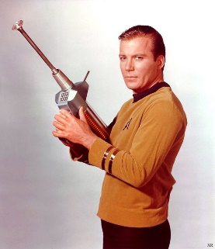
"Five U.S. Senators Are Space Aliens" by swanksalot is licensed under CC BY-NC-SA 2.0 "Autopsy of Space Alien, Roswell" by martnpro is licensed under CC BY-NC-ND 2.0 "Space Aliens Grill & Bar, Fargo, North Dakota" by Mathieu Croisetière is licensed under CC BY-SA 2.0 "Bass Performance Hall Angel" by TexasEagle is licensed under CC BY-NC 2.0 "Digital Graphic Novel Drawing of Angels at Caesars Palace by Charles W. Bailey, Jr." by Charles W. Bailey, Jr., Digital Artist is licensed under CC BY-NC 2.0

